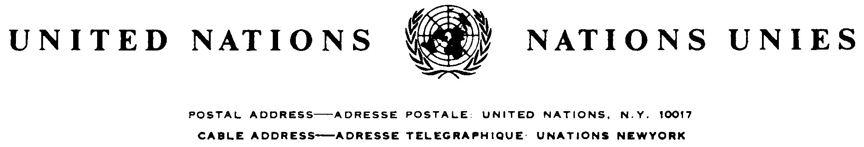

Reference: C.N.1204.2003.TREATIES-1 (Depositary Notification)

CONVENTION ON THE PREVENTION AND PUNISHMENT OF THE CRIME OF GENOCIDE

NEW YORK, 9 DECEMBER 1948

Sudan: Accession

The Secretary-General of the United Nations, acting in his capacity as depositary, communicates the following:

The above action was effected on 13 October 2003.

The Convention will enter into force for the Sudan on 11 January 2004 in accordance with its article XIII (3) which reads as follows:

"Any ratification or accession effected subsequent to the latter date [... the date of deposit of the twentieth instrument of ratification or accession] shall become effective on the ninetieth day following the deposit of the instrument of ratification or accession."

14 October 2003
